CERTIFICATE OF COMPLETION

«First_Name» «Last_Name»
HIPAA

October 17, 2017
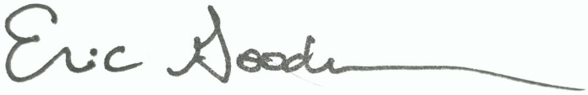

_____________________________________________________________________
Dr. Eric Goodman, Vice President of Education

